**LAND PROPERTY/ASSET ADDRESS**

Address:Click here to enter text.

House Number:* **:** Click here to enter text.

Locality\***:** Click here to enter text.

Town:* Choose an item.

Municipal/District:*Choose an item.

Region:*Choose an item.

Digital Address:*Click here to enter text. (Click link to generate Digital Address <https://www.ghanapostgps.com/map/>)

Longitude No: Click here to enter text. (Click link to generate Digital Address <https://www.ghanapostgps.com/map/>)

Latitude No:Click here to enter text. (Click link to generate Digital Address <https://www.ghanapostgps.com/map/>)

*The link above when clicked generates both longitude and latitude data also so the longitude and latitude data automatically fall in their respective boxes*

P. O. Box/PMB Number:Click here to enter text.

Site plan Number:Click here to enter text.

Land Size: 100 feet by 100 feet

Scan Site Plan QR Image:(Open camera to scan QR code and save)

Attach Site Plan: (Open camera to snap site plan or attach site plan image) OCR generates data on the site plan attached/scanned/snapped by opening camera and integrating all data acquired from the site plan onto the similar table below

Create a Mockup design of this site plan as it is displayed and make every clickable aspect clickable compared to the samples below. The OCR software will pick all the coordinate on the image and integrate them here. The following plan is the front image and the back follows beneath

Create an account for surveyors and solicitors to also view submitted plans, they can approve or query any plan uploaded and submitted by client.

The Map, Terrain, Satellite is to enable user click any part of it and it will be manifested on a google map utilizing Google earth/globe API design

|  |  |  |  |
| --- | --- | --- | --- |
| PLAN OF LAND  FOR:Click here to enter text. | | | |
| Scale:Click here to enter text. | | Area:Click here to enter text. | |
| LOCALITY:  Click here to enter text. | DISTRICT/METRO/MUNICIPAL:  Choose an item. | REGION: :Choose an item. | |
|  | | | |
| I, Click here to enter text. Licensed surveyor hereby certify that this plan is faithfully and correctly executed and accurately shows the land within the limits of the description given to me by my client.  E Date: 11/19/2024 | | Approved Seal  Upload Signature here or click here to digitally sign | Approved by  Regional Surveyor phone:  ______________ |
| Lic. Surveyor’s Number:___________ |

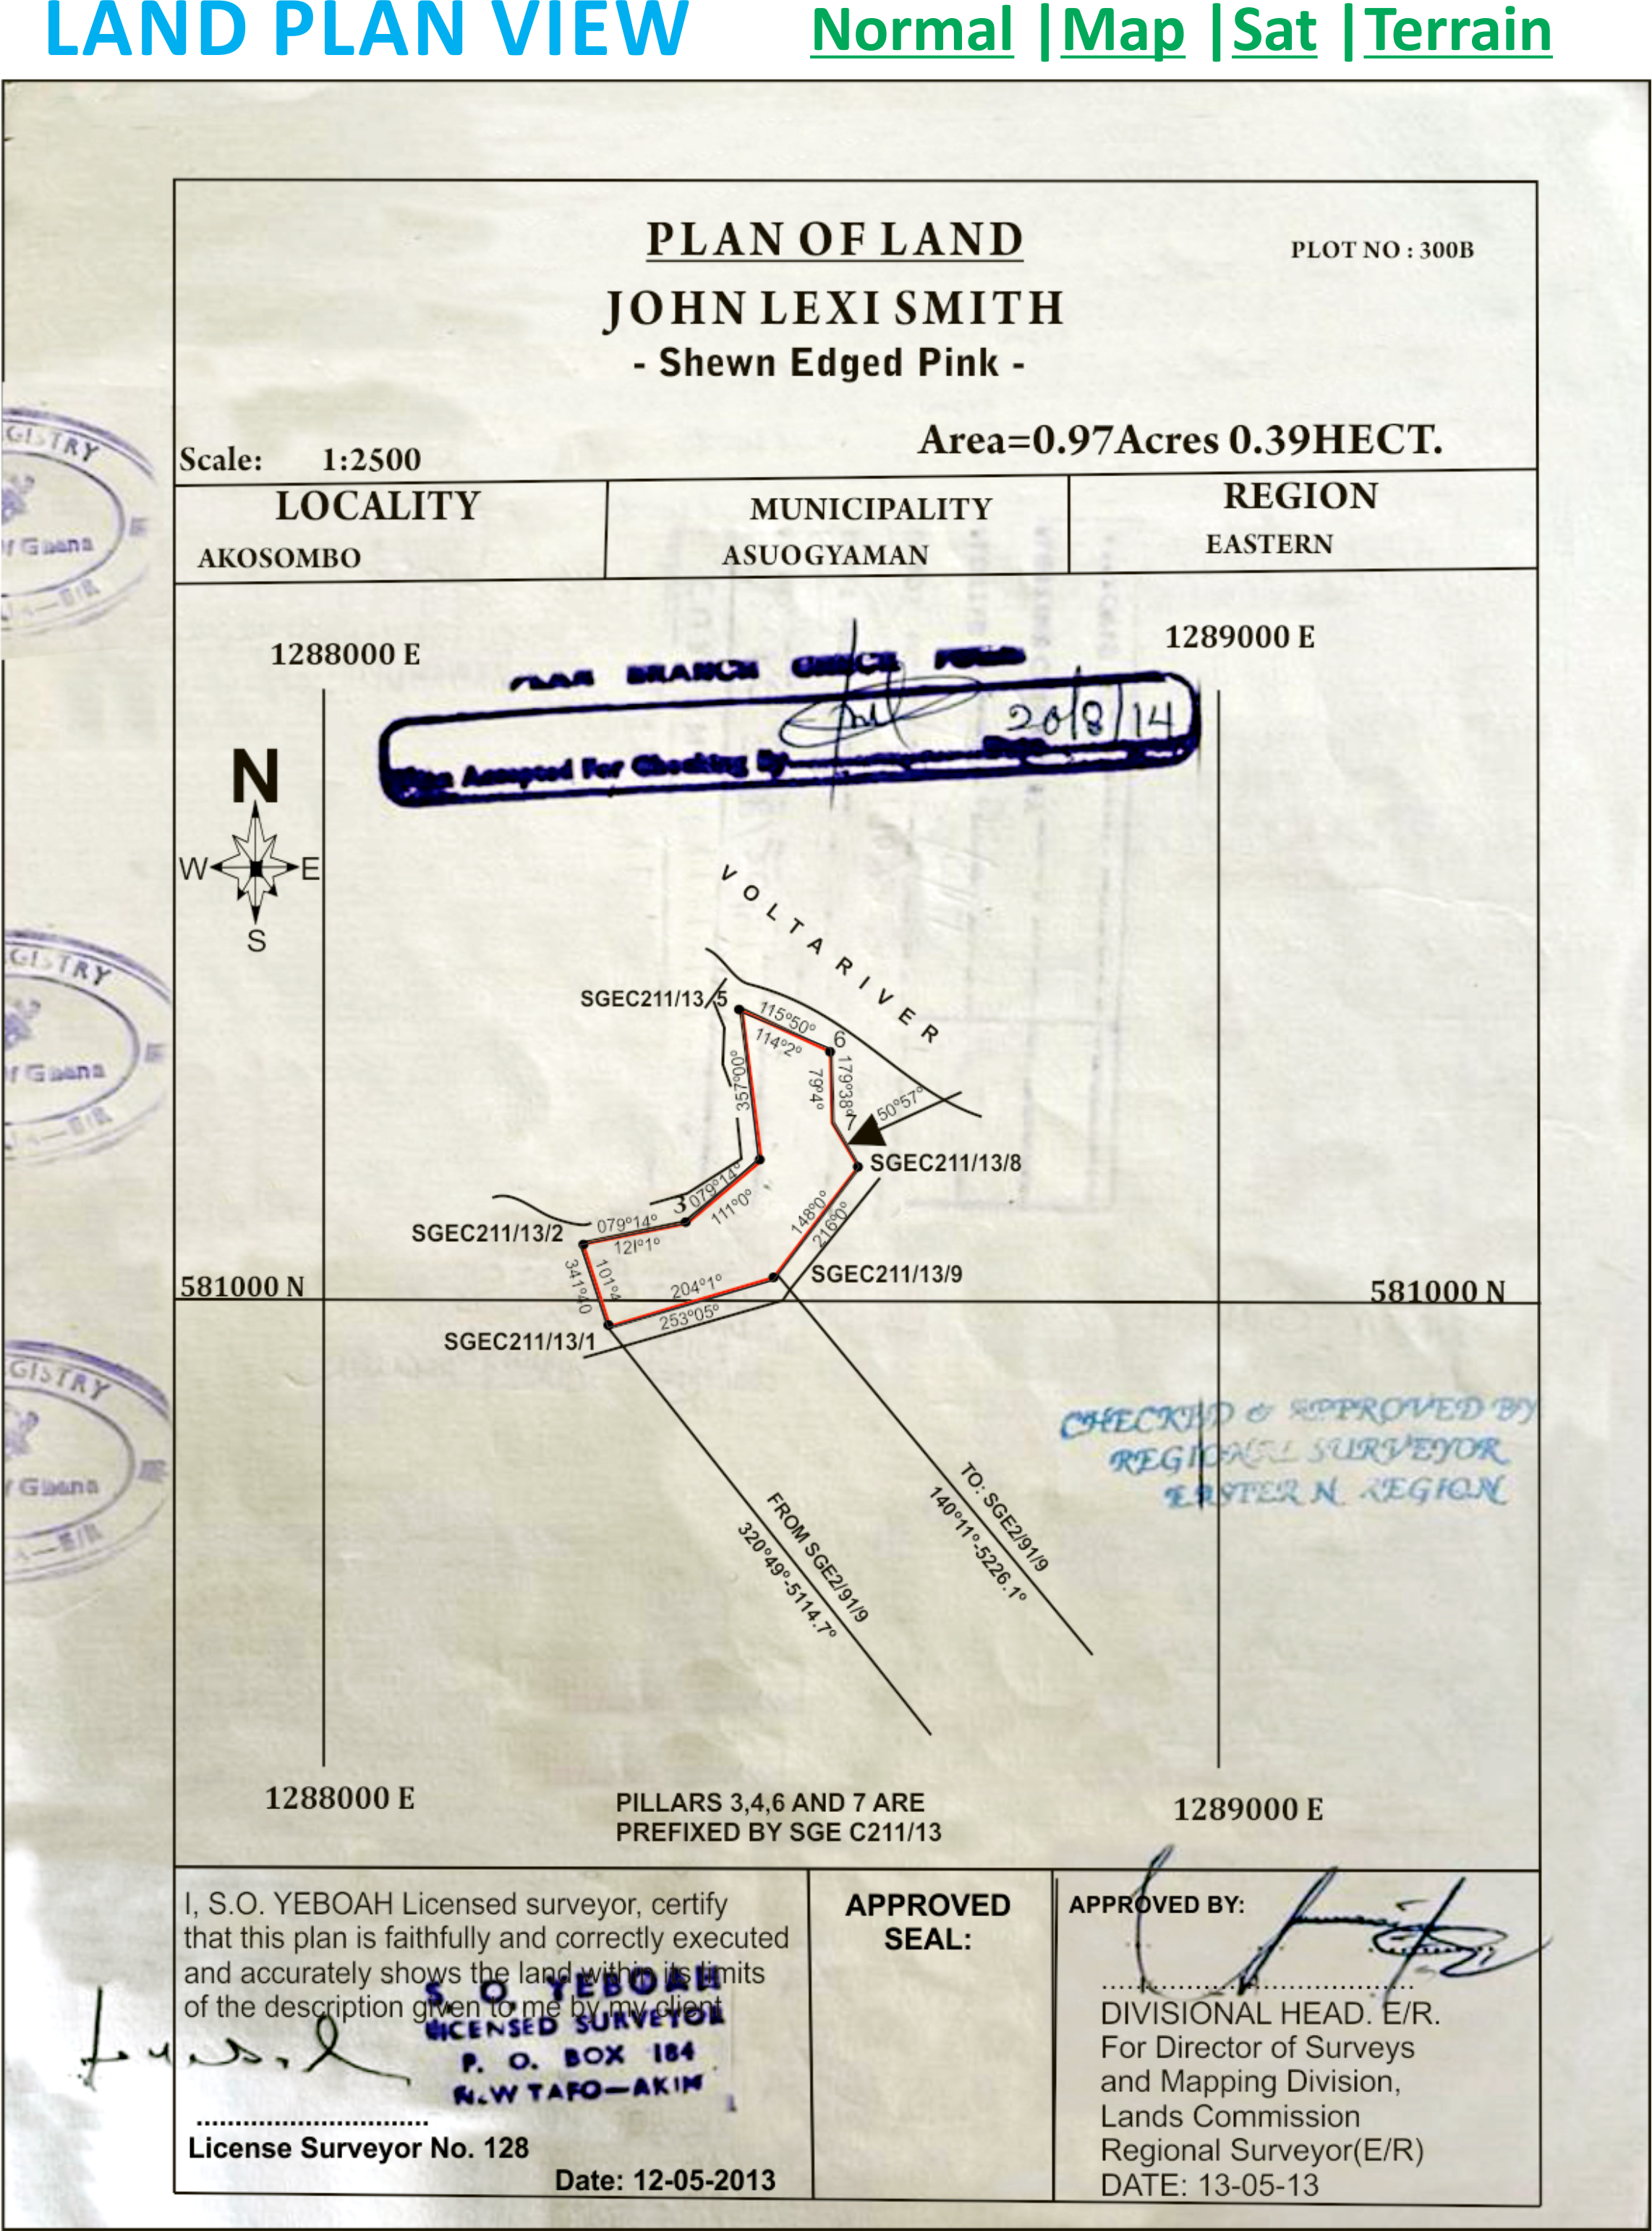

**BACK OF SITE PLAN**

|  |
| --- |
| QR Code  QR Code Number  Bar Code  Barcode Number here  The lessor/seller signs and stamp on this part of the land/site plan |

**BACK OF SCANNED/SNAPPED SITE PLAN**

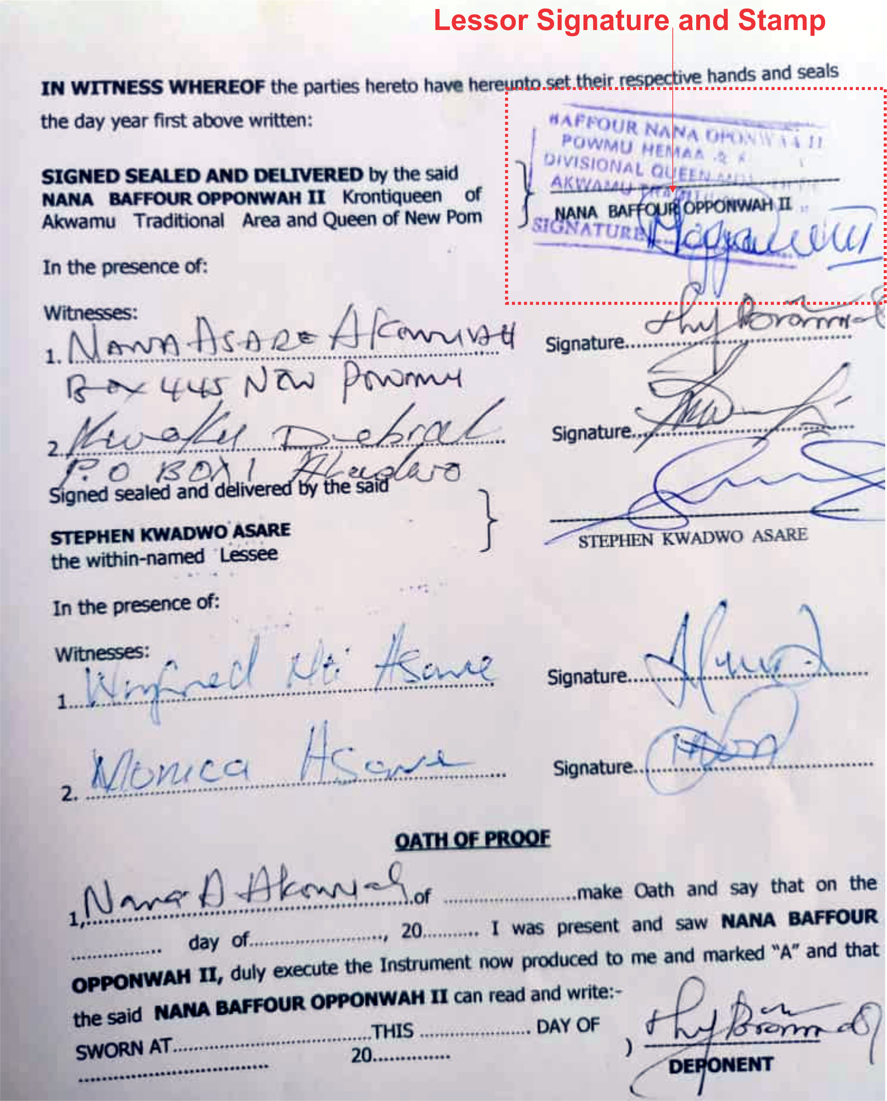

**ADD PILLARS+**

**Pillar 1 Details**

Pillar Number 1:Click here to enter text.

Click this link to generate Pillar digital address number   
<https://www.ghanapostgps.com/map/>)

Pillar 1 digital address numberClick here to enter text.

Pillar Images: (Camera will be opened for 2 photos to be taken or attachment)

**CONTRACT/INDENTURE/AGREEMENT DETAILS:**

*This Indenture is between the parties herein:*

ADD REPRESENTING PARTIES

**REPRESENTATION FORM**

For easy and fast registration, click this link to invite REP to fill only this portion of the form

Representing as PARTY “A”

Representing as: Seller/Lessor, Buyer/Lessee, AgentWitness Deponent Solicitor

Representing as/for: IndividualOrganization Stool Community Clan Family

In a capacity as: Head Subordinate Next of Kin Representative Consultant Facilitator

**TITLE:**Choose an item. Title NumeralsChoose an item.

**NAME:________________ PHONE:_____________ E-MAIL:__________**

**Is this person Living:** Yes No if No kindly attach a Witness by inviting them to this form to witness/verify this transaction

SEND OTP ENTER OTP_____________ VERIFY OTP

**Indenture Details**

**TERM: Select Number of years Start Period 9/13/2024 End Period 9/13/2024**

Indenture files: Multiple attachment allowed

**AGREEMENT:** Click to add Files and Click to add Images

|  |
| --- |
| Enter Agreement Text here |

**ADD Title Concurrence details Yellow Card**

**TITLE/CONCURRENCE/YELLOW CARD FORM**

Number:____________________(Add attachment)

I don’t have yet I haven’t applied yet I don’t need yet I will apply later

I applied on 9/12/2024/ and will be ready on 9/12/2024/

**I want**

**Basic:** Duration: 12 months, Fee: GH¢500.00

**Standard:** Duration: 6 months, Fee: GH¢2,500.00

**Fast Track:** Duration: 3 months, Fee: GH¢2,500.00

**Gold:** Duration: 1 month Fee GH¢10,000.00

**Prestige:** You will be contacted for Estimated Time of Completion and Cost

These prices are entered by ARVIPOA Admin for site plan application, any plan picked allows the user to make payment and receives Estimated time of delivery sms and in app notification

Click here to apply for new Title/Concurrence/Yellow card (This link will take you to the payment platform)

Payment Code:___________________

END OF LAND REGISTRATION

What do you want to do with this just registered land: Add a House/building facility

Agricultural project Personal Use Nothing for now Sell Lease Mortgage Rent Collateral Gift Will Caretaking